Lab Assignment 3

Name- Keshav Garg

Id- 2018UCP1674

Schema (Q1-Q5):

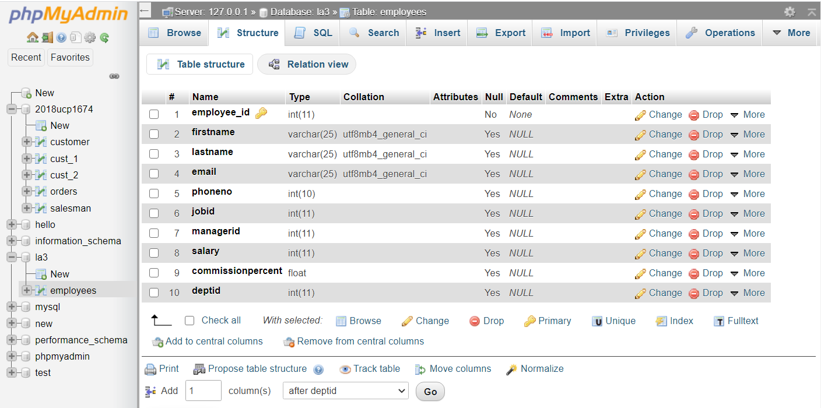

Ans1. INSERT INTO employees VALUES (155,'A','a','a@gamil.com', 1234567890,1000,160,5000,10,1),

(156,'B','b','b@gamil.com',1432567890,1001,160,4500,10,2), (157,'C','c','C@gamil.com',1234567809,1000,162,9000,10,3), (158,'D','d','d@gamil.com',3214567890,1023,169,2500,10,4), (159,'E','e','e@gamil.com',1234567890,1002,159,5000,10,5), (160,'F','f','f@gamil.com',1234567890,1000,160,5000,10,1), (161,'G','g','g@gamil.com',1234567890,1005,160,700,10,1), (162,'H','h','h@gamil.com',1234567890,1023,161,8000,10,1), (163,'I','i','i@gamil.com',1234567890,1000,160,7500,10,1), (164,'J','j','j@gamil.com',1234567890,1001,162,5000,10,1), (165,'K','k','k@gamil.com',1234567890,1023,160,1000,10,1), (166,'L','l','l@gamil.com',1234567890,1006,161,800,10,1), (167,'M','m','m@gamil.com',1234567890,1012,162,5000,10,1), (168,'N','n','n@gamil.com',1234567890,1004,160,1000,10,1), (169,'O','o','o@gamil.com',1234567890,1023,160,3000,10,1), (170,'P','p','p@gamil.com',1234567890,1013,161,500,10,1);

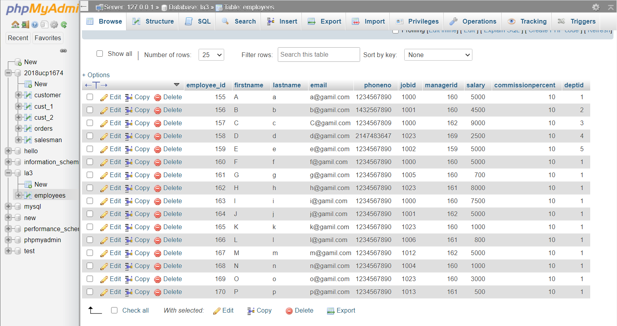

Ans2. [SELECT](http://localhost/phpmyadmin/url.php?url=https://dev.mysql.com/doc/refman/5.5/en/select.html) firstname, lastname FROM employees e WHERE e.salary> ([SELECT](http://localhost/phpmyadmin/url.php?url=https://dev.mysql.com/doc/refman/5.5/en/select.html) salary FROM employees WHERE employees.employee_id=163);

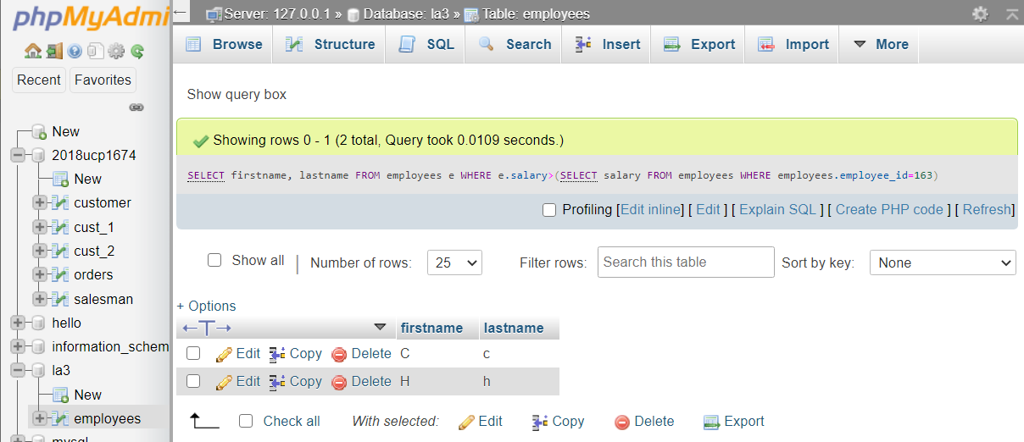

Ans3. SELECT firstname, lastname, salary,deptid, jobid FROM employees e WHERE e.jobid=(SELECT jobid FROM employees WHERE employees.employee_id=169);

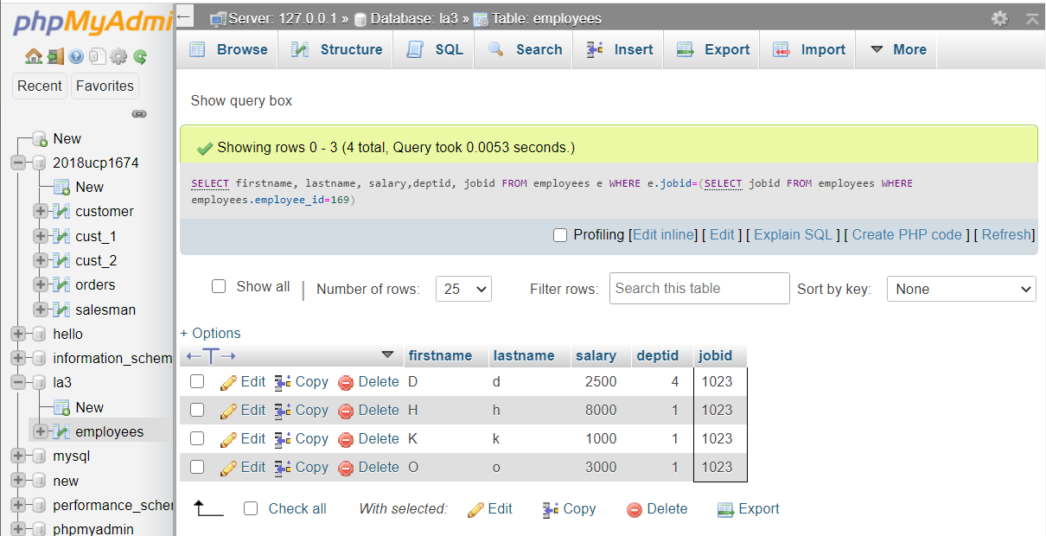

Ans4. SELECT * FROM employees e WHERE e.managerid IN(SELECT managerid FROM employees WHERE employees.employee_id IN(161,162));

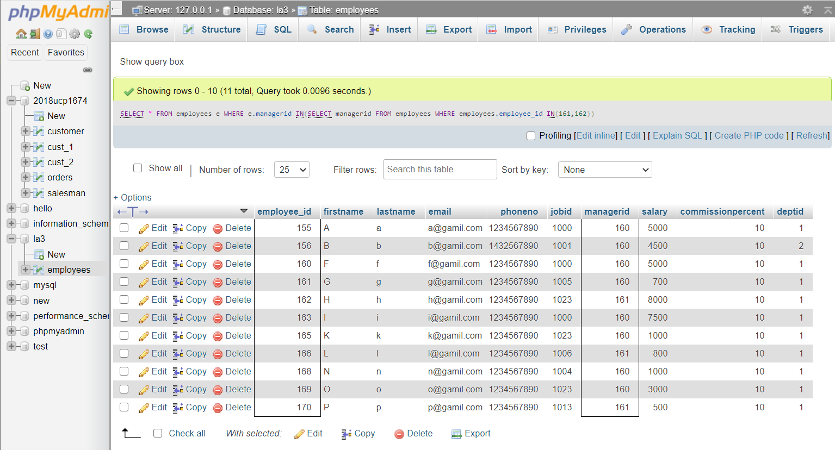

Ans5. SELECT * FROM employees e WHERE e.salary BETWEEN (SELECT MIN(salary) from employees) AND 2500;

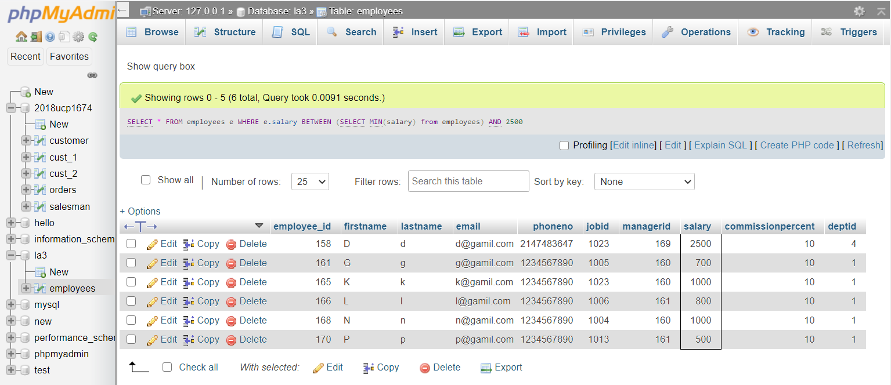

Schema (Q6-Q10):

Customer Table:

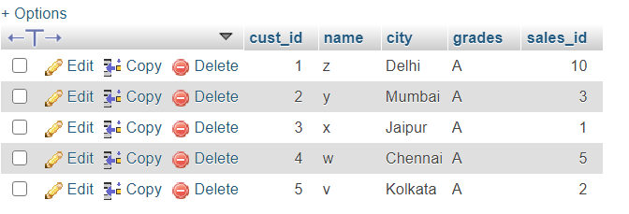

Orders Table:

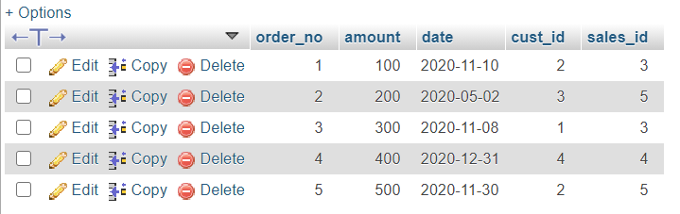

Salesman Table:

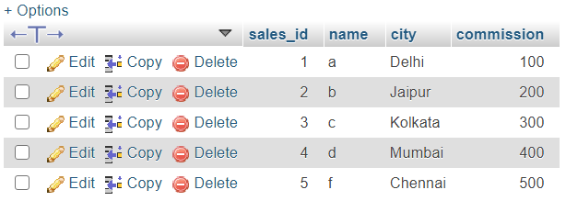

Ans6. SELECT name FROM customer c WHERE c.sales_id IN(SELECT sales_id FROM orders a WHERE EXISTS (SELECT * FROM orders b WHERE a.sales_id=b.sales_id AND a.order_no<>b.order_no AND DATEDIFF(a.date,b.date)=5));

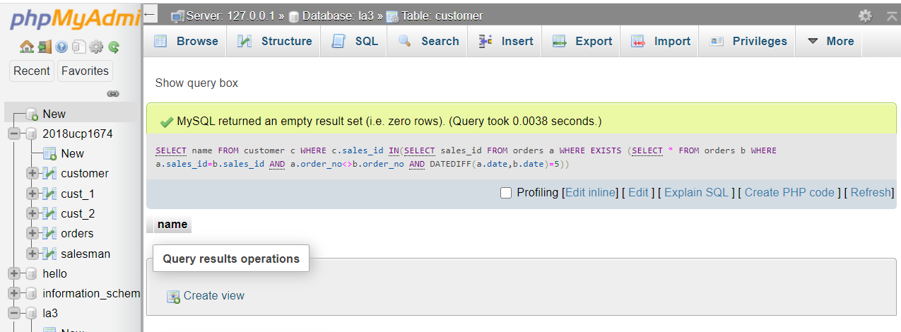

Ans7. SELECT DISTINCT order_no, min(date), cust_id from orders GROUP BY cust_id;

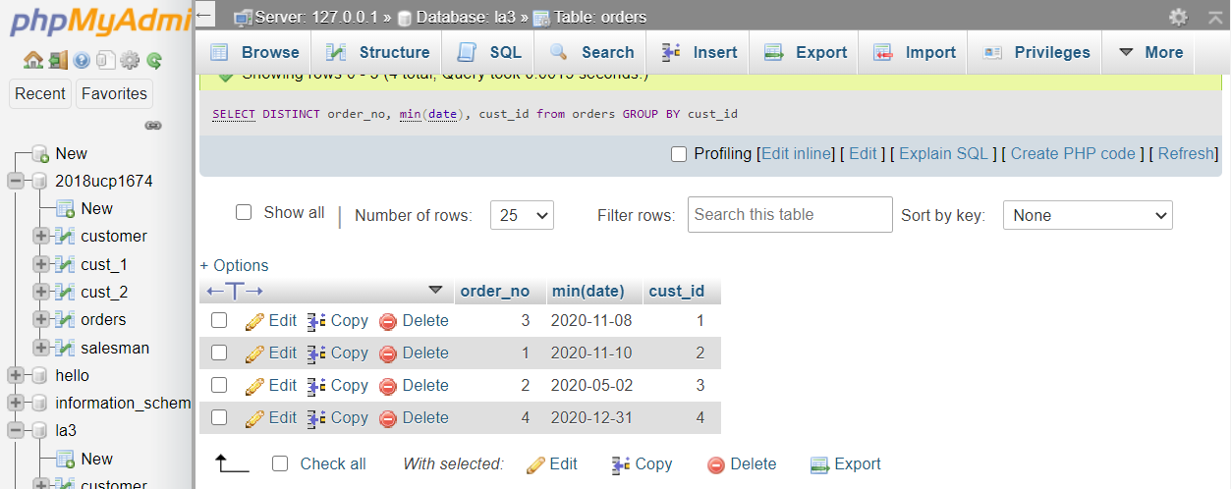

Ans8. [SELECT](http://localhost/phpmyadmin/url.php?url=https://dev.mysql.com/doc/refman/5.5/en/select.html) * FROM orders WHERE DAY(orders.date) [IN](http://localhost/phpmyadmin/url.php?url=https://dev.mysql.com/doc/refman/5.5/en/comparison-operators.html#function_in) (30,29,28,31);

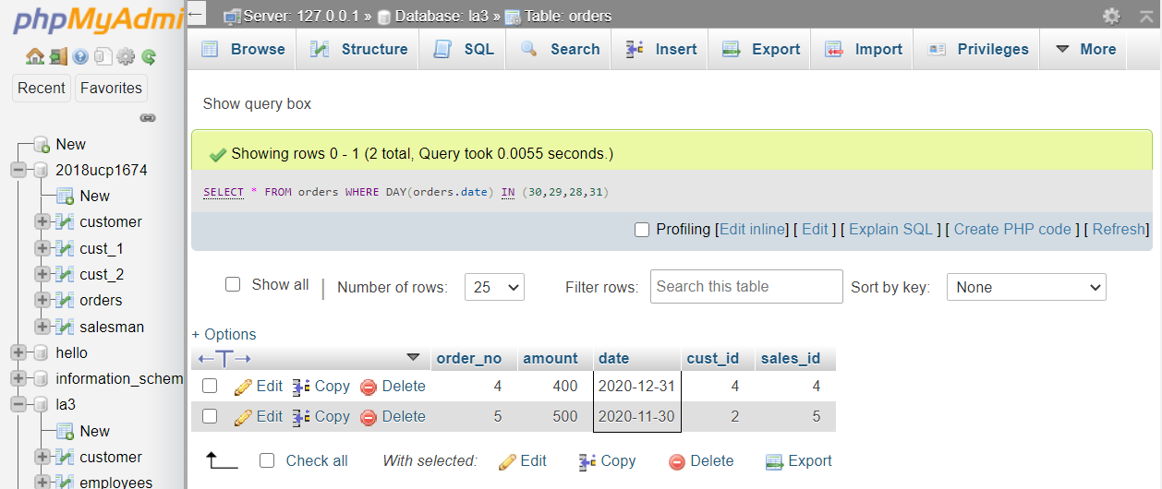

Ans9. SELECT (COUNT(order_no)) as NumberOFOrders, c.cust_id FROM customer c, orders o where c.cust_id=o.cust_id GROUP BY o.cust_id;

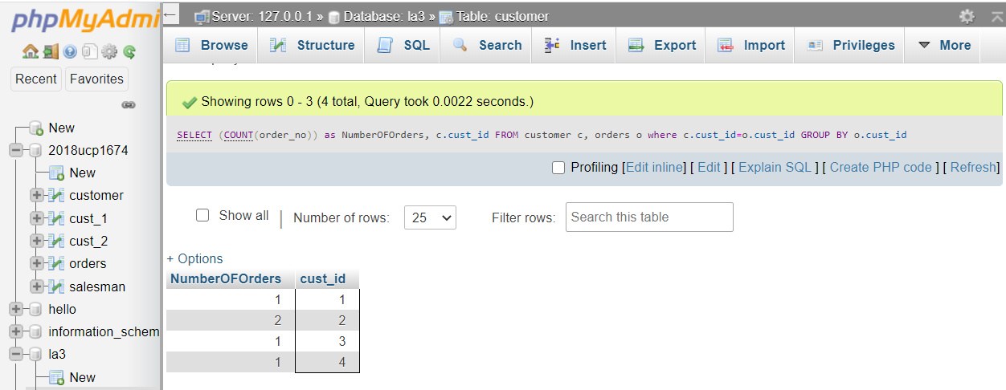

Ans10. SELECT s.sales_id,c.cust_id FROM salesman s,customer c WHERE c.sales_id IN (SELECT sales_id FROM customer a WHERE a.sales_id<>s.sales_id) ORDER BY s.sales_id,c.cust_id ASC;

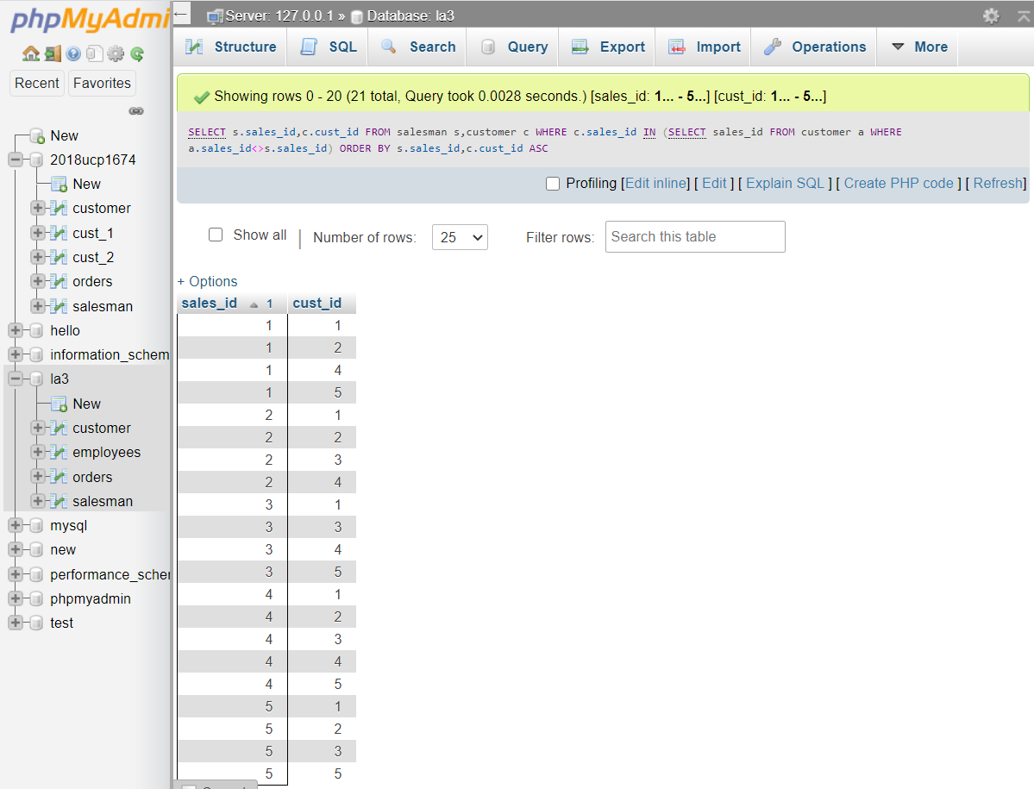

-------END-------